**— TENDER & QUOTATION —**

Provision of   
Service and Maintenance of the Fire Detection & Alarm   
Systems, Ansuls and Sprinklers

For the attention of:  
Brendan O Connor, Chief Executive,  
Stewarts Care Limited,  
Mill Lane, Palmerstown, Dublin 20 (D20 XT80)

***Due***: (12:00pm) on Wednesday 14-October-2022  
(one hard copy/one electronic copy)

***Submitted by:***

Crothers

Tel +353 1 456 7947

Email : info@crothers.ie

139 St Peter's Rd, Walkinstown

Dublin 12, D12 N83P

Solution House T +353 1 4567947 Reg no: 13952

139 St. Peters Rd, F +353 1 4569119 Vat no: 4884779P

Walkinstown, E info @ crothers.ie Directors: Steven Crothers,

Dublin 12, Ireland W www . crothers.ie Martin Crothers, Colin Crothers

**_______________________**

**Contents**

**Understanding of Requirements 1**

Compliance with Tender 1

**Company Profile 1**

Present Contracts 4

References 5

Insurance 6

Turnover 8

Tax Clearance 9

Certifications 10

**Personnel Details 12**

Contact Information for Principles 12

Details of Accounts Team 12

Training  13

Organisational Chart 14

**Management of Project 15**

Confidentiality 15

Change Control 15

Quality Assurance 16

Complaints Procedure 19

Reporting and Repairs Methodology 21

Document Control Procedures 24

Maintenance Procedures 26

**Annex - Staff Qualifications (C.V.s) 30**

**Annex 38**

Attachment - Auditor’s Statement 38

.

# Understanding of Requirements

Crothers understands we are responding the Request for Tenders for Quarterly Servicing & Maintenance of the Fire Detection & Alarm Systems , and sprinkler systems and hose reels, bi annual service and maintenance of the Ansul Systems. Any contract that may result from the award of a Services Contract will be issued for a term of one (1) year and one (1) option year. Crothers is uniquely positioned to serve Stewarts Care, as we are Small and Medium Enterprise (SME) with more 20 years’ experience in this business. Crothers is not relying on the capacity of other entities to carry out this effort. Crothers guarantees pricing and all other terms and conditions for this response as valid for no less than 60 days after submission. We accept the provisions of the RFT (see signed statement).

Crothers will provide a main contact point/attended telephone helpline (not a recording or a message system) for all queries, directly accessible by all Stewarts Technical Services and Security personnel. All Crothers contractors (including sub-contractors) coming on to Stewarts site will be trained in Manual Handling and will have completed the relevant training to carry out their tasks. Training records will be provided. Our team will have their own Personal Protective Equipment (PPE) and use it as required by the task and signage displayed. Crothers personnel follow all current recommendations for the use of Personal Protective Equipment (PPE) for use in a pandemic setting, and all our staff have inoculations up to date.

## Compliance with Tender

|  |  |
| --- | --- |
| **Compliance Criteria** | **Page** |
| Document Control Procedure | 24 |
| Staff /engineers training and qualifications | 13, 30 |
| Reporting and repairs methodology | 21 |
| Company certifications | 10 |
| Complaints procedures | 19 |
| Organisational chart | 14 |
| Insurance certificate | 6 |
| Tax clearance certificate | 9 |
| Descriptive details of similar contracts Contact information for references | 4,5 |

# Company Profile

Crothers was founded in 1984 in Dublin. Crothers has grown to a full-service security systems provider. Our alarm monitoring services monitor alarm systems of all specification, not just in the greater Dublin area, but throughout the Republic — from basic systems through to the latest, state-of-the-art systems, and from domestic systems to large industrial and commercial complexes.

With our fleet of fully equipped and stocked G.P.S. tracked vans we have a huge flexibility which allows us to respond to urgent service calls immediately, 24 hours a day, 365 days a year. In addition, our computerised call system means that all calls are centrally logged and followed through to completion. We offer 24-hour / 7-day secure monitoring of all security and CCTV systems. Our staff complete works dockets and certification on site on their mobile device and this paperwork is sent electronically in real time to the client, so the responsible person has complete visibility around the contract at all times.

Our client list includes Dara residential services, Sophia Housing, Hail Housing, Respond Housing, Cuala Property Management, H.S.E., pasted-image.tiffArdmore Studios.

Crothers Security has been awarded the prestigious ISIA “Locksmith of the Year” award for 2013, 2015, 2016 and again in 2018 & 2021. This award is based on customer satisfaction surveys and is a reflection of our commitment to customer care and service levels.

*The range of services and products you provide*. Crothers provides installation, maintenance, and monitoring of:

* + Commercial alarms and security systems,
  + CCTV systems,
  + Fire alarms and Emergency Lighting,
  + Access control and Intercoms, and
  + Locks and Safes.

Crothers addresses the full range of alarm handling services — everything from basic digital communications to a fully integrated security systems with integrated CCTV and visual verification. Keeping an organisation, its items, its data and customers safe is paramount. At Crothers, we supply alarm, fire, and CCTV systems across a range of requirements. Safety of personnel is even more important than the safety of a property, which is why we offer access control, health and safety and fire monitoring systems for large commercial and industrial sites.

We are a second generation family firm run by two brothers, Martin Crothers & Steven Crothers who have over 50 years experience in the security business between them. We strongly believe in standards and quality in the security industry. Martin Crothers is a Past President of the Irish Security Industry Association and has been a member of several Working Groups which worked very closely with the Private Security Authority in developing standards for licensing of CCTV, Access Control & Locks. He has recently completed a Diploma in Asset Risk Management with The Security Institute of Ireland

Our primary business is installation & servicing of small to medium size Security and Fire Systems, incorporating Physical Maintenance such as Door Closers, Locks, Panic Exit Devices & Door Maintenance as part of our overall maintenance package.

We are a Customer Focused, Service Driven company with a dedicated operations manager who’s primary role is to ensure service calls are managed and scheduled efficiently:

* + We design, supply, install and maintain a wide range of security products including Intruder Alarms, Fire Alarms, CCTV, Access Control, Locks, Doors, Door Closers, Panic Exit Devices and Safes.
  + We specialise in bundling CCTV, Fire, Intruder, maintenance, packages and Sub-contract certain elements such as Key-Holding & Fire Extinguisher Maintenance. We use only carefully chosen sub-contractors and we manage them closely so that the service is seamless for the client.
  + We have a Retail Outlet in Walkinstown with large stores for Spares/ Stock and our offices are there also, which comprise of a main office and meeting rooms.
  + We have a fleet of 5 Vans, all run Centrally through our Operations Manager, June Nolan who has over 25 years experience.
  + We have bespoke Service Management software which tracks all calls to conclusion and contract and accounts software which manages all contracts
  + Our I.T. support is out sourced and we have full external system back-up
  + Hard copies of System files are kept in Fire-Proof storage on site.
  + All vans are fully equipped with diagnostic equipment, Laptops for programming & Spares.
  + Our after-hours service provides full out of hours back-up.
  + Depending on the panels, we can dial in remotely and remedy many problems without the need for a call out

Our alarm Monitoring company carries out communication tests on all panels and reports on this & any activations are sent by Email and reviewed every morning. Intruder Alarm Monitoring; (Smartmonitoring.ie)

## Present Contracts

 #1

|  |  |
| --- | --- |
| **Client Name:** | **Hail Housing** |
| Reference Contact  Name: Role:  E-Mail Address:  Phone No: | Cathal Maher  Technical Officer  [Cathal@hail.ie](mailto:Cathal@hail.ie)  01 671 8444 |
| Description of the services  provided | **Maintenance / Service / Replacement of Intruder Alarms, Fire Alarms, fire Extinguishers Emergency Lights, Access Control** |
| Describe the relevance of this example to the current requirement. | Hail Housing provide supported accommodation across over 300 premises for people with a range of challenges from intellectual disability to previous addiction issues. Crothers provide annual scheduled maintenance on Intruder Alarms ,Fire Alarms & Emergency Lighting for their accommodation portfolio across Dublin & Leinster. We also provide reactive, emergency call outs and upgrades of systems as required.  We provide support to staff with ongoing training on procedures for carrying out periodic manual fire alarm testing etc.  We carry out this work in individual homes and ensure that our approach is sympathetic and empathic to the service user’s needs and sensitivities.  We also understand the importance of providing support to Hail staff in the form of fast response times, timely reporting and providing information on the conditions of all systems, so that annual budgets for upgrades can be managed |
| Duration of Contract | 3 years |
| Approx. Contract Value (€) | €40,000 |

 #2

|  |  |
| --- | --- |
| **Client Name:** | **Sophia Housing** |
| Reference Contact  Name: Role:  E-Mail Address:  Phone No: | Susie O’Keeffe  Assistant Head of Services  [sokeeffe@sophia.ie](mailto:sokeeffe@sophia.ie)  01 473 8300 |
| Description of the services  provided | Maintenance / Service / Replacement of Intruder Alarms Fire Alarms, Fire Extinguishers Emergency Lights, Access Control. |

|  |  |
| --- | --- |
| Describe the relevance of this example to the current  requirement. | Sophia Housing Association provides supported accommodation for people who have a history of homelessness. Crothers provide annual scheduled maintenance on Intruder Alarms, Fire Alarms & Emergency Lighting for their accommodation portfolio in Dublin. These are in large apartment blocks and on campus. We also provide reactive, emergency call outs and upgrades of systems as required.  We provide support to staff with ongoing training on procedures for carrying out periodic manual fire alarm testing etc.  We carry out this work in individual apartments / houses and ensure that our approach is sympathetic and empathic to the service user’s needs and sensitivities.  We are flexible in our scheduling to ensure minimum disruption to residents  We work with staff to ensure that the environment is a completely safe one, and complies with Dublin City Council requirements |
| Duration of Contract | 3 years |
| Approx. Contract Value (€) | €17,000 |

 #3

|  |  |
| --- | --- |
| **Client Name:** | **Dara Community Living** |
| Reference Contact details  Name: Role:  E-Mail Address:  Phone No: | Sean Lennon  Services Manager  [seanl@daracommunityliving.ie](mailto:seanl@daracommunityliving.ie)    0873705719 |
| Description of the services  provided | Annual Monitoring & Maintenance of Intruder Alarms, Fire Alarms & Emergency Lighting |
| Describe the relevance of this example to the current  requirement. | Dara Community Living provide a range of support services including supported accommodation to adults with intellectual disabilities across 20 premises. Crothers provide annual scheduled maintenance & monitoring on Fire Alarms, Intruder Alarms & Emergency Lighting for their accommodation portfolio across Dublin & Kildare. We also provide reactive, emergency call outs and upgrades of systems as required.  We provide support to staff with ongoing training on procedures for carrying out periodic manual fire alarm testing etc and liase with our monitoring partners to ensure signals are received.  We carry out this work in individual homes and ensure that our approach is sympathetic and empathic to the service user’s needs and sensitivities.  We also work closely with the service manager to ensure all certs, paperwork etc are issued in a timely manner so that the stringent audits from HIQUA are successful. |
| Duration of Contract | 5 years |
| Approx. Contract Value (€) | €16,000.00 |

## Insurance

Crothers agrees to hold for the term of the Services Contract the following insurances:

**Type of Insurance Indemnity Limit**

Employer’s Liability €13 Million

Public Liability €6.5 Million

Product Liability €13 Million

The territorial limits and jurisdiction of our insurance policies include Ireland. We will supply a formal confirmation from Crothers insurance company to this effect prior to award.

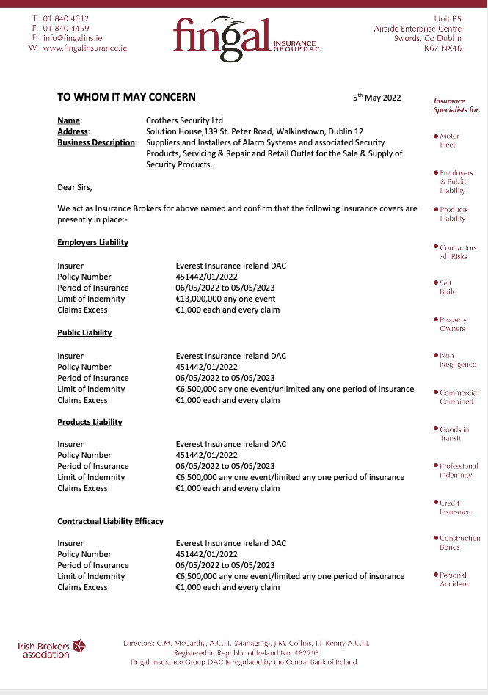

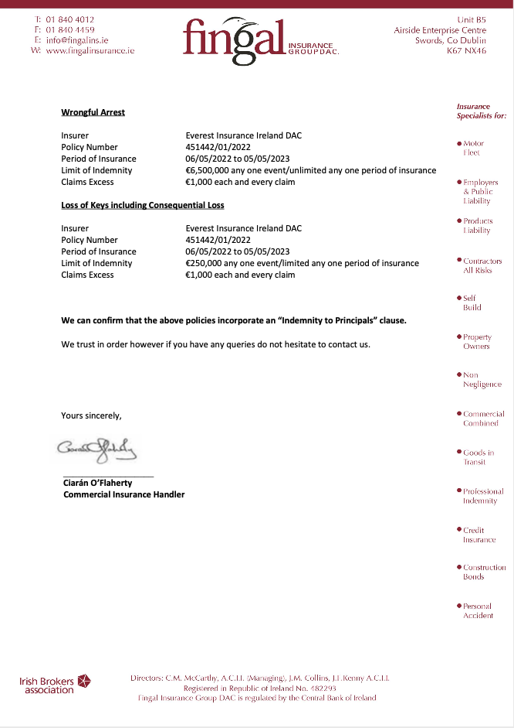

## Turnover

|  |  |
| --- | --- |
| **Year** | **Financial Turnover** |
| 2019 |  |
| 2020 |  |
| 2021 |  |

*The name and address of our bank*:

AIB Bank, Main St, Dundrum

*Please enclose a copy of your last three years audited returns with your proposal*. See Annex.

*Tax clearance access pin and log on details* to [www.revenue.ie](http://www.revenue.ie) :

__**684958**_______________

## Tax Clearance

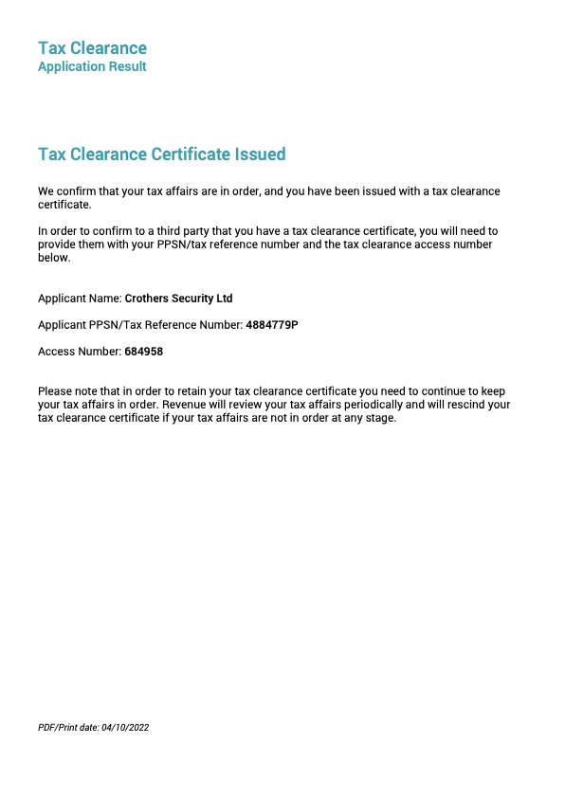

## Certifications



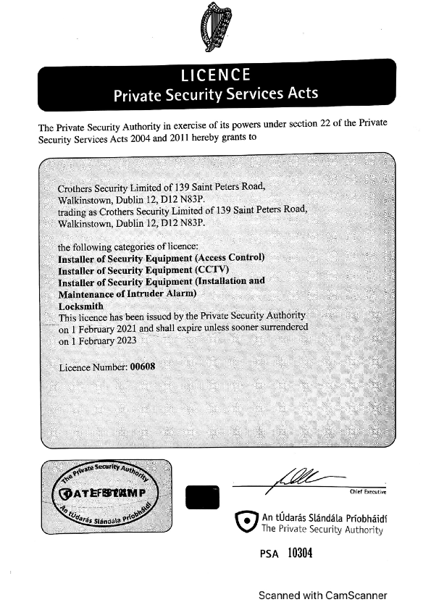

# Personnel Details

Crothers views this opportunity as of highest priority, and we are naming one of our Managing Directors as the primary Contracts Contact so we may ensure the best level of customer care for Stewarts.

## Contact Information for Principles

| **Position** | Name | Title | Location | Contact Information |
| --- | --- | --- | --- | --- |
| Contracts Contact | Martin Crothers | Managing Director | Headquarters | Phone: 014567947  Mobile: +353 862271535 Email: [martincrothers@crothers.ie](mailto:martincrothers@crothers.ie) |
| Alternate Contact | Steven Crothers | Managing Director | Headquarters | Phone: 014567947 Mobile: +353 862404660 Email: [stevencrothers@crothers.ie](mailto:stevencrothers@crothers.ie) |
| Account Manager | TBD |  | Headquarters |  |

## Details of Accounts Team

| **Position** | Name | Role | Location | Contact Information | Qualifications & Experience |
| --- | --- | --- | --- | --- | --- |
| Team member 1 | June Nolan | Operations Manager | HQ | Phone: 014567947  Mobile: +353 862271535  Email: [junenolan@crothers.ie](mailto:junenolan@crothers.ie) | 30 years in the security industry as accounts and operations manager |
| Team member 2 | Colm Kavanagh | Electronic Systems Technician | HQ or field | Phone: 014567947  Email: [colm@crothers.ie](mailto:colm@crothers.ie) | 6 years combined apprentice and master levels. Member of Associated Locksmiths of Ireland |
| Team member 3 | Bernard Gahan | Technician | HQ or field | Phone: 014567947  Email: [bernard@crothers.ie](mailto:bernard@crothers.ie) | 4 Year Carpentry Apprenticeship. 2 year Locksmith & Security Equipment Installation  Trade Courses on Abloy, Fire Exit Regulations, Yale Lock Installation Courses |
| Team member 4 | Dean Colley | Electronic Systems Technician | HQ or field | Email: [dean@crothers.ie](mailto:dean@crothers.ie) | 3 year on the job Apprenticeship of Security Systems Installation  Fetac Level 5 Security Systems Technician Dun Laoire ETB  Various Product training courses including HKC, HikVision & Risco  Specialist Training in Access Control including Siemens, ACT & Paxton |
| Team member 5 | Gary O'Connell | Electronic Systems Technician | HQ or field | Email: [gary@crothers.ie](mailto:gary@crothers.ie) | 3 year on the job Apprenticeship of Security Systems Installation  Various Product training courses including HKC, HikVision & Risco  Specialist Training in Access Control, ACT, Paxton , Siemens |
| Team member 6 | Alan Farrell | Technician | Field | Phone: 014567947  Email: [alan@crothers.ie](mailto:alan@crothers.ie) | 4 Year Carpentry Apprenticeship. 2 year Locksmith & Security Equipment Installation  Trade Courses on Abloy, Fire Exit Regulations, Yale Lock Installation Courses |
| Team member 7 | Gary Deans | Electronic Systems Technician | Field | Email: [GaryD@crothers.ie](mailto:GaryD@crothers.ie) | 3 year combined apprenticeship of Security Systems Installation and Service |

## Training

* Manual Handling Training – All staff trained
* Safe Pass – All those required to access construction sites have been trained
* MEWPS Training – All required staff trained

## Organisational Chart

# Management of Project

Crothers uses a service level agreement (SLA) approach to management of projects such as this one. The SLA is an agreement with vendors or contractors whose work is crucial to the project being delivered or completed on time. A project management services agreement will outline the steps the customer would take if the agreed level of service was not upheld. At Crothers, a service level agreement can also be helpful to facilitate collaboration with the client to provide details on the means of reporting issues, and timelines for service. Our SLAs cover two areas: services and management. The service section will include the list of services we will provide, as well as those excluded, the duties and responsibilities of each party, the expected response and resolution time, as well as escalation procedures and service credits if the vendor or provider does not meet the agreed level of service. The management section of the SLA for project management will include methods and standards of measurement of the service, the reporting and conflict resolution processes, as well as any indemnification details.

## Confidentiality

Crothers undertakes to comply with all reasonable directions of the Client with regard to the use and application of all and any of its Confidential Information and shall comply with the confidentiality agreement as exhibited at Appendix 6 to the RFT (“the Confidentiality Agreement”). We will supply a signed copy, printed on our letterhead, upon contract award. We acknowledge that the security of the State and its information is of paramount importance to the Client. Accordingly, Crothers confirms that it will, if requested by the Client, from time to time, submit full personal details (including those of Subcontractors) who are assigned to provide the Services (or any part thereof) under the project. We understand that checks may be carried out in relation to all such personnel by police authorities and Crothers will comply with all reasonable directions of the Client arising therefrom. Further, Crothers certifies we will comply with all applicable requirements of the Data Protection Laws, Directive 95/46/EC (the “General Data Protection Regulation”), and any guidelines and codes of practice issued by the Office of the Data Protection Commission or other supervisory authority for data protection in Ireland.

We have carried out a conflicts of interest check and we are satisfied that neither Crothers nor any Subcontractor nor agent has any conflicts to perform service to the Client. Crothers will notify the Client immediately should any potential conflict of interest come to our attention, and we will comply with the Client’s directions in respect thereof. All Crothers personnel who will be required to attend any/all Stewart’s sites will complete Garda vetting prior to working onsite

## Change Control

A change control notice (“Change Control Notice”) will be prepared for all change requests. The Change Control Notice will provide an outline description of the change requested, the rationale for the change, the effect that the change will have on the Services (where known) and an estimate of the effort and cost required to prepare an impact assessment (“Impact Assessment”). Crothers and the Client must indicate acceptance of the change control request and/or Impact Assessment within a reasonable timeframe of its completion and Tender Submission for review, subject to a maximum of twenty (20) calendar days or such other period agreed by both parties.

## Quality Assurance

*State whether your company has attained any certification, and the areas in which it has been achieved*.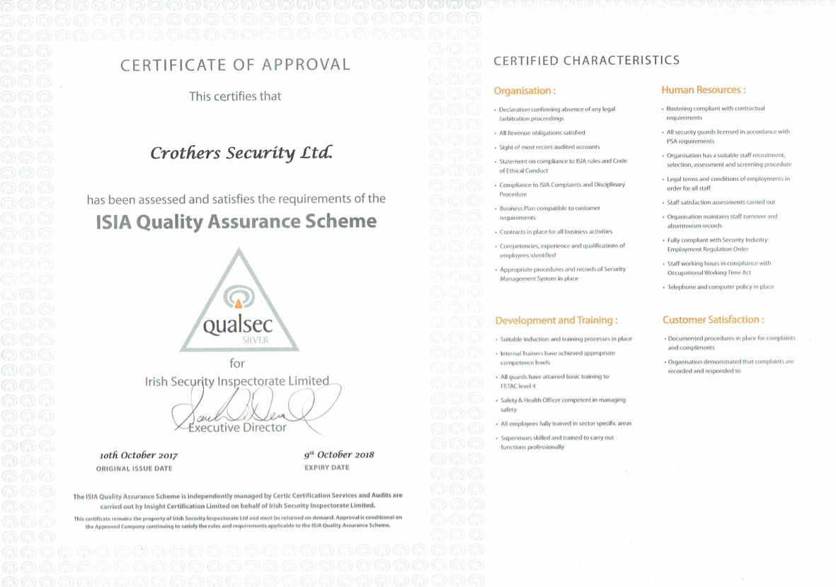

*Define your documented quality system. If no documented system exits, define how conformance to customer requirements is assured*. We are members of The Irish Security Industry Association (I.S.I.A.) and are Holders of the Qualsec Silver Standard. This I.S.I.A. quality scheme is independently managed by Certic Certification Services and Audits are carried out by Insight Certification Ltd. on behalf of Irish Security Inspectorate Ltd.This Quality Standard ensures that the standard of Staff Training, Recruitment & H.R., Policies and Procedures support the Standards of Service, Quality and Value for Money that we aspire to achieve. We are also Certified by the EQA for S.R.40 & EN. 50131 and Licensed by the P.S.A. for Intruder, CCTV & Access Control

*What process do you have in place to ensure best-in-class quality of service?* Service Culture is built on elements of leadership, work habits and Crothers vision. Our vision is to help the customer fulfill their mission and supporting them in the pursuit of their organizational objectives. Employee Engagement focuses on staff attitude, purpose driven leadership and our human resources processes. Service Quality includes strategies, processes and performance management systems. Customer Experience includes account management and continuous improvements. We have found that successful service delivery works on the basis that the customer is a part of the delivery of our services. We shape processes built on that philosophy.

*What standard reports you provide to clients*? Service Call Summary; Works Docket with issue, resolution & further action required. Calls list by period, Parts Used List, Transaction Listing (Current and by Period); Invoice, Payments, Transactions. Fire Register Log Book, Periodic Maintenance Certification

*What escalation procedures you would put in place for this contract?* We have a customer complaints procedure though in practice for contract customers there is rarely need to follow this or escalate it as your Contract Manager (Martin Crothers) would be your primary point of contact and will take personal responsibility for resolving any issues at an early stage. Following is a depiction of of corrective & preventative action procedures.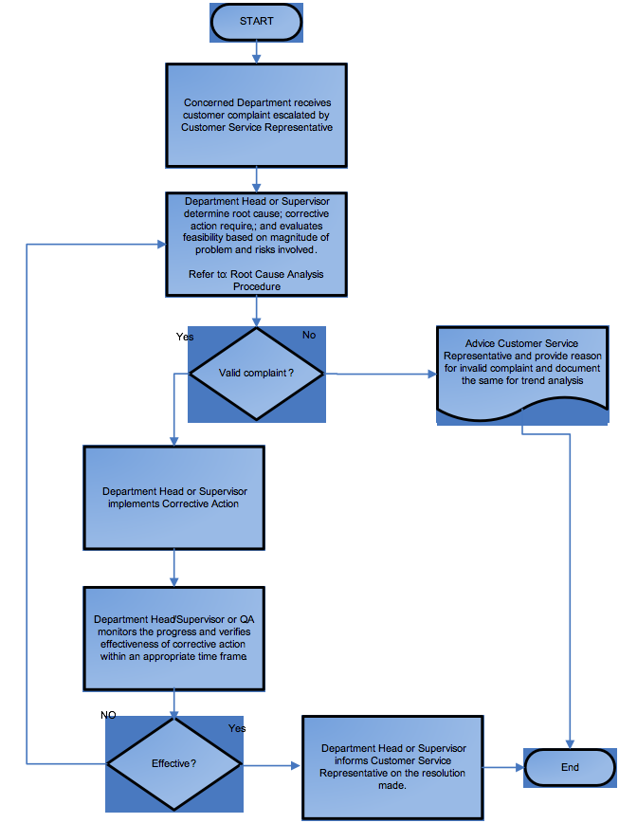

*List details of reporting methodology, processes and procedures* (Please provide a copy of the document control procedure). When a technical arrives on a customer site, our work order tracking system automatically records the date and time of arrival. The technical is presented with a checklist of routine tasks and any additional work, as required. Upon finishing, the the date and time of completion is recorded. The on-site authorised customer signs the work order, and a notification is automatically dispatched to our account management team. If additional services are required, an updated work order is dispatched. The work performed is logged in our accounts system.

*Company safety statement, details of any safety certification and accident register for the past two years*.

Crothers strives to ensure that our security services activities operate as safely as possible. This means thorough service preparation, a trained staff, and processes that are adhered to. Crothers will comply with all applicable regulations and limit inherent work risks to the maximum extent possible. Crothers’ policy is to comply with the terms of applicable legislation and local authority conditions to provide and maintain and safe and healthy environment for staff. The objective of the health and safety policy is to minimise accidents or situations which might endanger the health, safety or welfare of any and all persons in connection with our business.

Crothers recognises that it is responsible for ensuring so far as is reasonably practicable the health and safety and welfare at work for our team. It will only be possible for us to comply with these obligations if both its employees and any customers or other affected third parties understand that they are under a duty to take reasonable care for the health and safety of themselves and any others who may be affected by their acts or omissions and that they are required to cooperate with us to enable our company to perform its obligations. Any incident which results in an injury must be reported in writing to company management.

An important part of a safety management system is having the right culture within Crothers. Crothers strives to create a culture whereby learning from incidents is paramount to the improvement of operational processes. This requires an honest acknowledgement of mistakes by the personnel involved. Obviously, incidents are not desirable, however, Crothers views incidents as an opportunity to learn, and increase safety within Crothers professional activities. As such, a just culture is supported. When researching incidents, the identification of the cause of the incident is the focal point of the investigation and not the individuals involved. We track incidents in a log maintained at our offices. We fully investigate any incidents, issue an incident report, and follow up to implement learning opportunities to address processes so we may improve safety. The company has had no significant safety issues in more than three years.

## Complaints Procedure

Crothers defines a complaint as: “A complaint is an expression of dissatisfaction by one or more members of the public about an organisation’s action or lack of action, or about the standard of service provided by or on behalf of the organisation”.

Our policy is that every complaint requires a response. Crothers provides multiple channels for access to lodge a complaint. We strive to signpost the role of any advocacy agencies operating within our sector, identifying their role in providing assistance. Crothers, via our web portal, ensure that all of service users have access to simple and clear information about how to make a complaint. This includes taking account of service users with particular requirements, such as those with intellectual disabilities, who are visually impaired, or with language difficulties, etc., in keeping with the EU Web Accessibility Directive (Directive (EU) 2016/2102, as incorporated into Irish Law), which affords people with disabilities with improved access to websites.

***Exhibit: General Approach to Complaints Processing***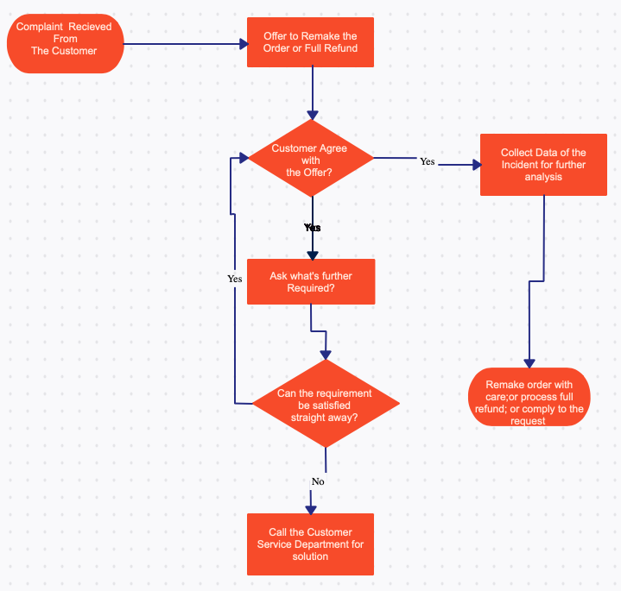

Information about the complaints procedure and policy is easily accessible at all times and not just when a service user wishes to complain. It is available at all public reception areas our Crothers offices, and any “common areas” which service users may use as well as being made widely available to all staff. Our complaints policy should is available through an easily accessed area of our website, which includes the name of the Complaints Officer and their contact details. We assure users that making a complaint will not adversely affect their ongoing interaction with us, and information about improvements made following previous complaints can be found on our website.

Crothers seeks to resolve service users’ complaints as early as possible and ideally, at the first point of contact. The stages in the complaint handling process are streamlined:

Frontline resolution should be completed within five (5) working days. Our staff will advise service users that they can progress their complaint on to the investigation stage if they are not satisfied with the outcome following attempts at frontline resolution.

## Reporting and Repairs Methodology

Work orders are used to request, assign, and track work that needs to be accomplished for maintenance, repair, and minor work efforts. The work order also serves to document the completion of work and to record all costs associated with that work (i.e., labor expenses, materials issued from inventory and other expenses incurred for purchase of materials or payment to contractors). The types of work orders are:

Corrective Work Orders: Corrective Work Orders are created for routine repair and/or maintenance of buildings and campus facilities. Corrective work orders are initiated internally by Crothers staff. Corrective work orders do not include non-maintenance work such as cabinet installation, hanging cables, installing signs or providing staffing support for special events outside of normal work hours (see Special Billing work orders below).

Service Request: Service Requests are corrective work orders requested from a customer external to Crothers.

Special Billing Work Order: Customer requests for non-maintenance work orders (examples: building new shelves, signage) with an estimated cost of less than €500 are billable to the requesting department.

Project: Customer requests for non-routine maintenance work with an estimated cost over €500 or for non-routine maintenance where tracking the involvement of multiple trades is beneficial (this does not include all multi-trade requests).

The Crothers business office will create a work order for tracking purposes when a request is neither billable nor corrective. Customer requests for estimated cost before proceeding with billable work can be initiated through mail, email, phone, or online.

Work orders are automatically generated on a scheduled frequency to ensure that routine (preventative) maintenance is performed. Crothers tracks work orders via a status code: Pending; Approved; In Process; Finished; Cancelled; Completed; Invoiced. Work order priorities are:

* + Emergency – used only when immediate response is required to avoid injury due to safety hazard, significant damage to university facilities (ex. flooding), or extended major disruption to university activities (ex. power outage).
  + Routine – default
  + Scheduled – scheduled work orders

All work orders must be completed in a timely manner or cancelled. Work orders cannot be deleted from the Crothers systems, for audit purposes. All completed work orders require documentation of labor and materials and any other direct costs incurred. Technicians completing the work are responsible for recording the hours worked as well as indicating if the charge is to be Regular Time (RT) or Overtime (OT). The cost of all materials used and any outside service expense must be recorded on the work order whether obtained through the inventory distribution system or purchased outside the inventory system, via purchase order.

Crothers personnel check for work requests submitted by e-mail or via online regularly during normal business hours and at the beginning of each business day. Work orders received by these methods are updated in our system as soon as possible. Crothers will provide automatic customer notification of work order creation and status changes unless the customer requests to not be notified. Updated work orders are distributed to the supervisors’ mailboxes at 10:30 am and 4:30 pm. For emergency work orders, Crothers personnel should contact appropriate customer contacts immediately. Routine contracted services provided by Crothers generally does not require a work order.

Reports are scheduled to automatically generate on a weekly basis each Monday: Supervisors; Corrective Work Orders Over 7 Days Old for their respective shop; Report lists work orders by age with oldest listed at top of report; All Work Orders Over 30 Days Old. Further, Managers and Company Directors receive same reports listed above for all customers under their management

***Exhibit: Communication Flow During Contract***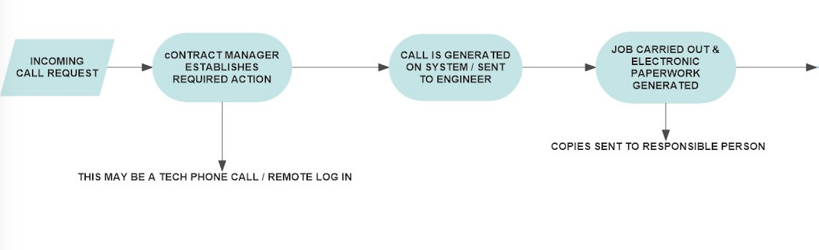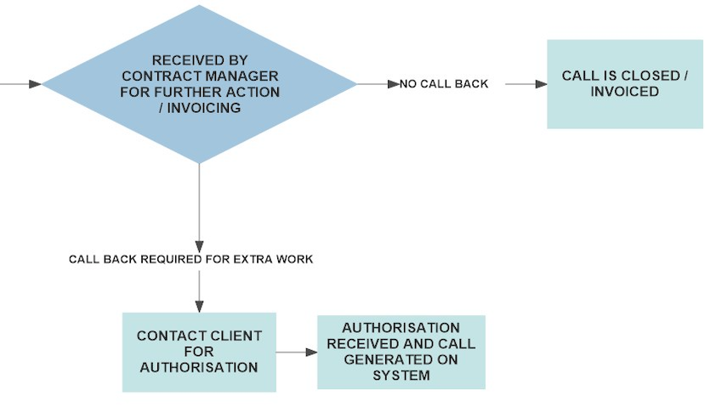

Supervisor and/or manager inputs comments received into the *Comments* section of work orders are processed by end of day each Friday so that the comments will be included in the next week’s reports.

***Sample Report***

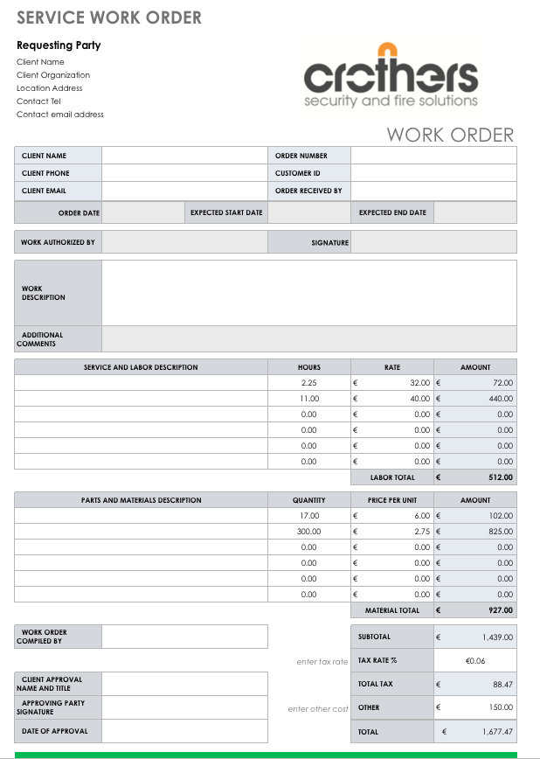

## Document Control Procedures

Crothers follows the ISO quality management standard – ISO 9001, Environment management – ISO 14001 or OHSAS – health and safety management, to maintain documents and records. This fully managed approach helps to find and document information used. Documents that are used in maintenance processes, dispatching, or any other process are maintained systematically for work flow purposes. The document control record is a master format that all the internal system document are listing to index the purpose of systems, standard operating procedures, and working flows. This is the basic requirement for document control records.

***Sample Document Control Record***

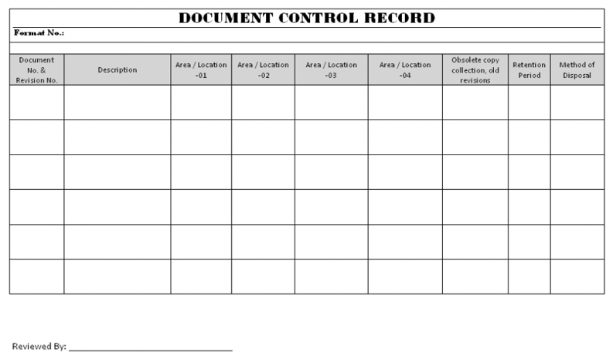

Crothers identifies all the documents to be managed within our control system. We have established quality standards based on our ISO processes, including a naming convention and revisions procedures. We manage access to documents based on staff role,, and this is controlled in our document management system. We also have steps for creation of documents, review, and archiving procedures.

Crothers has defined a numbering scheme for unique identification of forms, registers and lists, etc. For drawings the numbering scheme is used as per the site requirements, if not available the above scheme can be used by adding the site specific terms including project name. Crothers has defined a numbering scheme for unique identification of letters/memos which can be used for both internal & external correspondences.

These procedures cover activities including but not be limited to the following:

* Quality/ Environmental /Occupational Health & Safety Management System Manual
* Quality System procedures / Environmental System procedures & OHS system Procedures.
* Work Instructions / Method Statements
* Drawings, Technical Submittals, RFTs
* External Correspondences
* Legal and Regulatory documents
* Tech documents (Standard/specifications, machinery manuals etc)
* Audit reports
* Quality Control Checklists
* Forms & reports

After preparation and numbering of documents, they are reviewed and approved by the competent authority as applicable in case of project or work process-related documents. A record of distribution is maintained on document distribution form when printed copies are distributed. Any staff who needs, can initiate changes in controlled documents by filling in documents change request (DCR) form. The DCR is reviewed and approved by the competent authority as per review and approval procedure as mentioned above. The revision number of the corresponding document is incremented on the relevant page and the revised document is finally approved by the concerned authority. The revised document is then distributed to all concerned persons in the distribution list and the obsolete documents are retrieved.

***Document Management Process***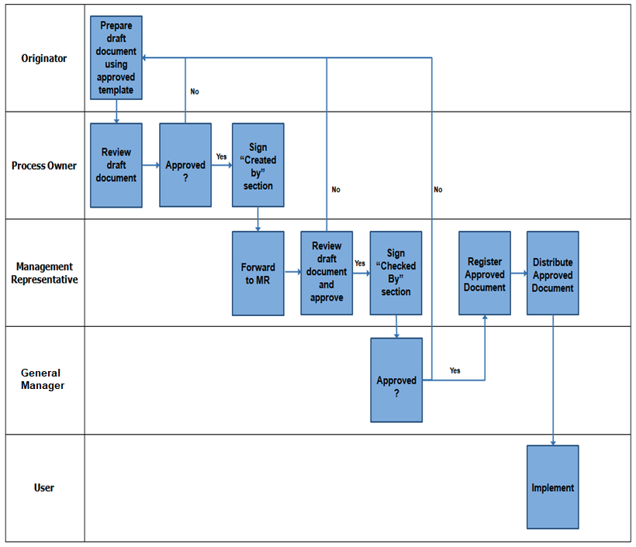

Obsolete documents are either destroyed or stamped “OBSOLETE” for proper identification. One copy of obsolete documents is maintained for record purpose. Quality manager or MR is responsible for controlling all these activities.

## Maintenance Procedures

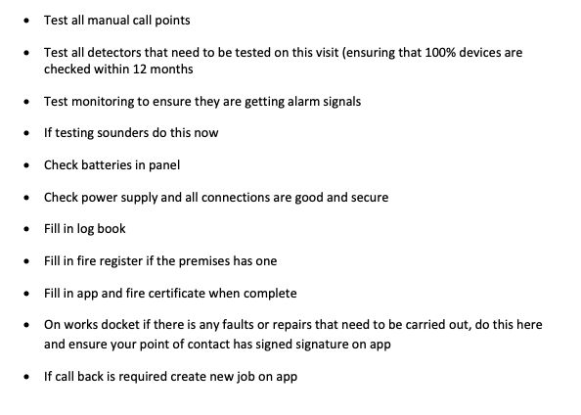

# Annex - Staff Qualifications (C.V.s)

**Martin Crothers (Dip.Sec.ARM)**

**Phone: 014567947 Mobile: +353 862271535**

Email: martincrothers@crothers.ie

**CAREER HISTORY**

Currently Director of Crothers Security with specific responsibility for Key Account Management, I have been with Crothers since 1992. I have recently completed a diploma in Asset Risk Management and have attended numerous courses and conferences on Fire Safety.

Passionate about professionalism & standards in the Security Industry.

Past President of Irish Security Industry Association (I.S.I.A.)

Former Chairman of the Electronic Division of the I.S.I.A.

Member of Private Security Authority Working Groups on CCTV Licensing and Access Control.

Previously a manager of a busy city centre fast food restaurant.

**Managing Director, Crothers Security Ltd. July 2003 - Present**

* Overall responsibility for the implementation of Company Strategy.
* Particular focus on building of maintenance contracts business.
* Personally responsible for attaining and retaining all mandatory standards and Qualsec (ISIA Quality Standard)

**Director , Crothers Security Ltd September 1992- July 2003**

* Developed H.R. Policies & Procedures
* Streamline management processes and introduced Operations Software

Oversaw transition from previous Managing Director

**Restaurant Manager, Argos Foods September 1989- September 2003**

* Responsible for developing Hygene & Quality standards.
* Direct responsibility for staff training programmes

**EDUCATION & TRAINING**

Diploma in Asset Risk Management at Advanced Level The Security Institute **25/05/2017**

**PROFESSIONAL MEMBERSHIPS**

Past President Irish Security Industry Association

**Steven Crothers (M.Sec.I.I.)**

**Phone: 014567947 Mobile: +353 862404660**

Email: Stevencrothers@crothers.ie

**CAREER HISTORY**

Currently Director of Crothers Security with specific responsibility for Technical Sales & System design, I have been with Crothers since 1989

I am also responsible for implementation of Health & Safety on Client’s Sites, specifically in the roles of PSDP & PSCS

My Specific role in this regard is to;

* co-ordinate the identification of hazards, the elimination of the hazards or the reduction of risks during installation;
* develop the safety and health plan specific to client’s site where required
* Ensure implementation of the construction regulations by Employees / contractors
* organise co-operation between External contractors and the provision of information pertaining to site
* co-ordinate the reporting of accidents to the H.S.A.
* provide information to the site safety representative
* co-ordinate the checking of safe working procedures
* co-ordinate arrangements to ensure that employees and sub-contractors Safe Pass.

Member of The Security Institute of Ireland

**Technical Sales Director, Crothers Security Ltd. July 2003 - Present**

* Responsible for system design & technical sales.
* Has developed several new products for the Crothers Portfolio of Security Solutions
* Liases with suppliers to ensure Technical staff are trained up on new products and kept abreast of new developments

**Security Installer, Crothers Security Ltd September 1992- 1999**

* Maintenance & Installation of Security Systems

**Apprentice Security Installer, Crothers Security Ltd September 1989- September 1992**

* Cabling & 1st fix of Security Systems

**EDUCATION & TRAINING**

4 year on the job Apprenticeship of Security Systems Installation

Diploma Entrance Course Security Institute of Ireland

Various Product training courses including HKC, HikVision & Risco

Various Client Specific Health & Safety Courses, including Intel, Henkel, Pfizer, Google

Safe Pass

**PROFESSIONAL MEMBERSHIPS**

Membership of Security Institute of Ireland

Member of Associated Locksmiths of Ireland

**Alan Farrell**

**Phone: 014567947**

Email: Alan@crothers.ie

**CAREER HISTORY**

Currently Security Installations & Service Engineer, Crothers Security Ltd

**Security Installer, Crothers Security Ltd September 2012- Present**

* Maintenance & Installation of Locks & Security Systems

**Trainee Security Installer Crothers Security Ltd September 2010-September 2012**

**Carpenter PJ Walls May 2006- September 2010**

**Apprentice Carpenter PJ Walls April 2002 – May 2006**

**EDUCATION & TRAINING**

4 Year Carpentry Apprenticeship. 2 year Locksmith & Security Equipment Installation

Trade Courses on Abloy, Fire Exit Regulations, Yale Lock Installation Courses

**June Nolan**

**Phone: 014567947 Mobile: +353 862271535**

Email: Junenolan@crothers.ie

**CAREER HISTORY**

Currently Operations Manager of Crothers Security with specific responsibility for day to day scheduling & organisation of jobs. I have been in the security industry since 1988

I was previously accounts manager with Allied Security Ltd (Now ADT)

**Accounts / Operations Manager, Crothers Security Ltd. July 1992 - Present**

* Overall responsibility for the day to day scheduling of work.
* Responsible for organising scheduled maintenances.
* Responsible for ensuring close out & resolution of all reactive service calls
* Responsible for invoicing & accounts reconciliation

**Accounts / Operations Manager, Allied Security Ltd August 1988- July 1992**

* Dealing with Key Accounts
* Responsible for account reconciliation
* Responsible for organising Scheduled maintenance

**Gary O’Connell**

Email: Gary@crothers.ie

**CAREER HISTORY**

Currently Security Systems Installer for Crothers Security Ltd, I have been in the Security industry since 2004

**Fire & Security Installer, Crothers Security Ltd March 2016- Present**

* Maintenance & Installation of Fire & Security Systems

**Fire & Security Installer, Iona Security May 2014- March 2016**

* Maintenance & Installation of Fire & Security Systems

**Fire & Security Installer Briarpark Security Jan 2012 – May 2014**

* Maintenance & Installation of Fire & Security Systems

**Fire & Security Installer Integral Security March 2010- Jan 2012**

* Maintenance & Installation of Fire & Security Systems

**Fire & Security Installer Briarpark Security May 2007 – March 2010**

* Maintenance & Installation of Fire & Security Systems

**Fire & Security Apprentice Alarm Fix Jan 2004 – March 2007**

* 1st Fix Cabling & Trainee installation of Fire & Security Systems

**EDUCATION & TRAINING**

3 year on the job Apprenticeship of Security Systems Installation

Various Product training courses including HKC, HikVision & Risco

Specialist Training in Access Control, ACT, Paxton , Siemens

**Dean Colley**

Email: Dean@crothers.ie

**CAREER HISTORY**

Currently Security Systems Installer for Crothers Security Ltd, I have been in the Security industry since 2010

**Fire & Security Installer, Crothers Security Ltd July 2017 - Present**

* Maintenance & Installation of Fire & Security Systems

**Fire & Security Installer, Vision Radio Fire May 2016 - July 2017**

* Maintenance & Installation of Fire & Security Systems

**Fire & Security Installer Crothers Security Ltd January 2015-May 2016**

**Fire & Security Installer Pioneer Security March 2013 - January 2015**

* Maintenance & Installation of Fire & Security Systems

**Fire & Security Apprentice AMSL Group January 2010 – March 2013**

* 1st Fix Cabling & Installation of Fire & Security Systems

**EDUCATION & TRAINING**

3 year on the job Apprenticeship of Security Systems Installation

Fetac Level 5 Security Systems Technician Dun Laoire ETB

Various Product training courses including HKC, HikVision & Risco

Specialist Training in Access Control including Siemens, ACT & Paxton

**Bernard Gahan**

**Phone: 014567947**

Email: Bernard@crothers.ie

**CAREER HISTORY**

Currently Electronic Security Installations & Service Engineer, Crothers Security Ltd

**Security Installer, Crothers Security Ltd September 2004- Present**

* Maintenance & Installation of Security Systems

**Trainee Security Installer Crothers Security Ltd September 2003-September 2004**

**Carpenter John Sisk & Sons May 2001- September 2003**

**Apprentice Carpenter John Sisk & Sons April 1997 – May 2001**

**EDUCATION & TRAINING**

4 Year Carpentry Apprenticeship. 2 year Locksmith & Security Equipment Installation

Trade Courses on Abloy, Fire Exit Regulations, Yale Lock Installation Courses

**Colm Kavanagh**

**Phone: 014567947**

Email: Colm@crothers.ie

**CAREER HISTORY**

Currently Electronic Security Installations & Service Engineer, Crothers Security Ltd

**Security Installer, Crothers Security Ltd September 2010- Present**

* Maintenance & Installation of Security Systems

**Apprentice Security Installer, Crothers Security Ltd September 2006- September 2010**

* Cabling & 1st fix of Security Systems

**Locksmith Crothers Security Ltd September 2004- September 2006**

**Apprentice Locksmith Crothers Security Ltd September 2002-September 2004**

**EDUCATION & TRAINING**

4 year on the job Apprenticeship of Security Systems Installation

Various Product training courses including HKC, HikVision & Risco

**PROFESSIONAL MEMBERSHIPS**

Member of Associated Locksmiths of Ireland

# Annex

## Attachment - Auditor’s Statement

